JOCO Art Show and Contest

Located at the JOCO Fairgrounds
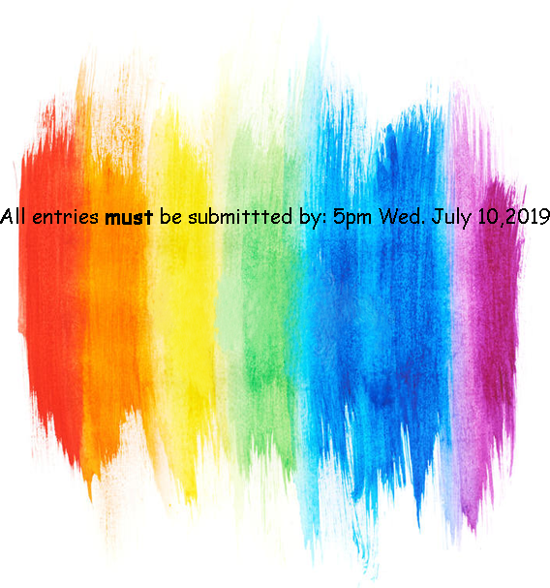
Wednesday, July 7, 2021
Check in: 3pm -5pm Judging: 6pm
Limited to TWO PIECES of art by same artist in show
rules are online at Johnson County Fair Association website https://www.johnsoncountyfairassociation.com
All artwork must be picked up by
5pm Saturday July 10. 2021

Paid Prizes for each category: Photograph,
Drawing, Painting and Sculpture
Place pay outs:
Professional 1st-$50 2nd-$25 3rd-$15 Open 1st-$25 2nd-$15 3rd-$10
OPEN TO THE PUBLIC
July 7- July 10
Sponsors:
Apple Bus | Dave‛s Auto
Black Kettle Ranch
Northside Feed |Seward Farms

